**PHY1002 Physics Laboratory**

**Short Report**

|  |  |  |  |
| --- | --- | --- | --- |
| Name: | Haopeng Chen | Student ID: | 120090645 |
| Group: | 8 | Date of Experiment: | Nov. 16th, 2021 |

**Experiment 6. Rotational Inertia (Physical Pendulum)**

1. For the rectangular bar pendulum, plot the $x$ (the distance between the pivot point and the center of gravity) vs. $T$ (period of a physical pendulum).

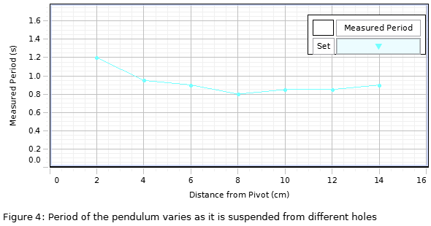

(a) Determine the $x$ that gives the minimum $T$.

As $T=2π\sqrt{\frac{\frac{1}{12}L^{2}+x^{2}}{gx}}$, we have $T\left(x\right)=2π\sqrt{\frac{1}{g}\left(\frac{L^{2}}{12}∙\frac{1}{x}+x\right)}$. $T$ got its minimum when $x=\sqrt{\frac{L^{2}}{12}}$. By measurement, the length of the bar $L=0.2800±0.0005 m$, so we get minimum $T while x=0.0808±0.0173 m$.

(b) Compare the experimental results from (a) with the theoretical values.

The experimental result meets the equation quite well.

2. Calculate the rotational inertia at the center of mass for a disk sample with the $M$, $T$, and d measured in the experiment. And compared with the theoretical value from the equation: $I=\frac{1}{2}MR^{2}$.

$$I_{cm}=\frac{T^{2}Mgd}{4π^{2}}-Md^{2}$$

$$=\frac{{\left(0.50s\right)}^{2}×0.0897kg×9.8m/s^{2} ×0.04m}{4π^{2}}-0.0897kg×{\left(0.04m\right)}^{2}$$

$$=(7.91±0.02)×{10}^{-5}kg∙m^{2}$$

$$I=\frac{1}{2}MR^{2}$$

$$=\frac{1}{2}×0.0897kg×(0.04{m)}^{2}$$

$$=(7.18±0.03)×{10}^{-5}kg∙m^{2}$$

They are coherent.

3. For irregular shape pendulum, plot the angular velocity vs. time curve and determine the constant angular acceleration. Calculate the rotational inertia at its center of mass.

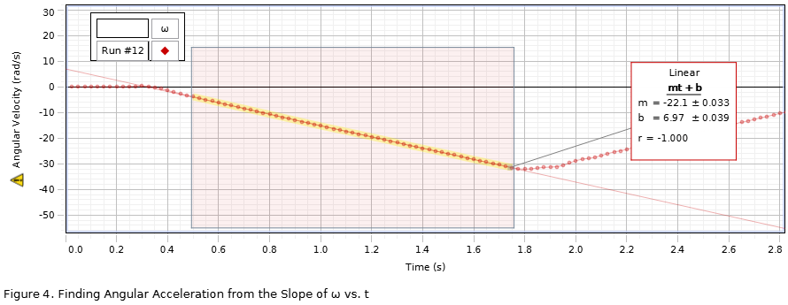

$I=\frac{mr(g-αr)}{α}$, where $α=22.100±0.033 rad/s$ is the angular acceleration, $r=0.0160±0.0005 m$ is the radius of the pulley and $m$ is the mass of $10g$. So $I=(6.84±0.03)×{10}^{-5}kg∙m^{2}$.

Appendix:

Attach the table in Exp 4B tab “Analysis 1” and “Part II”. (you should write a clear and detailed caption for each table.)

Analysis 1:

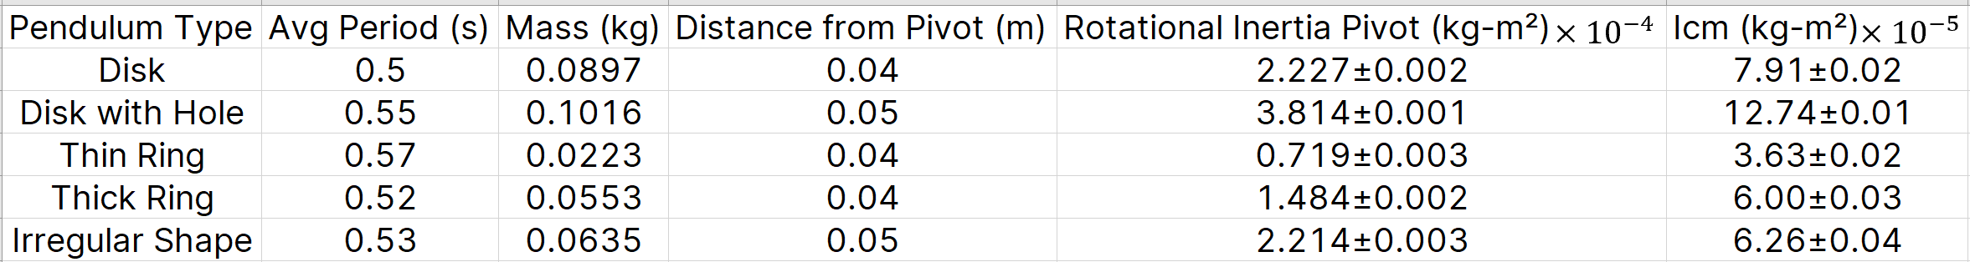

We fix the center of the thing onto the rotary sensor. Push it and start recording for 25 seconds. And with six times repeated, we take the average period. Then measure the mass and distance.

Part II:

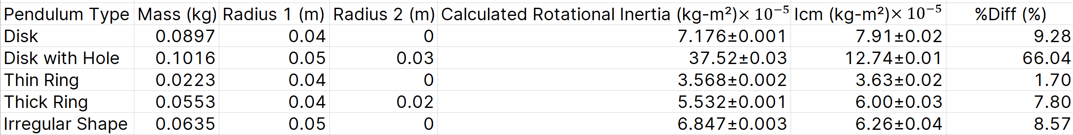

Use theory and mathematical deduction to calculate the inertia except Irregular Shape. For it, we use a $10g$ mass to act gravity on the disk, simulating a torque on this center-fixed disk. Then, the disk would rotate with an angular acceleration and we can use formula to calculate its inertia.

_____________________________________________________

--- End of Laboratory Report ---

**Notes:**

* **Submit soft copies online.**
* **No further modification allowed after deadline.**
* **Please don’t exceed 2 pages (exclude appendix), with normal margin and 1.0 line space.**
* **No figure is required if not specified.**